**Adi Electronics-Online Shopping**

**Adi Electronics**,a leading Electronic Shopping Store has decided to go online.They sell different products[The product and its price is given in the document].The Online shopping form template is as shown below.Payments are accepted in 3 modes.1)Cash On delivery 2)Debit Card 3)UPI Transfer. A Customer gets 5% discount on any product paid through Debit Card.Bag Total field computes the amount based on product,its quantity and payment mode.For a Bag Total of Rs.1 lakh and above,a coupon code [Coupon Code format:ADI followed by first 4 digits of Bag total ]gets generated and it can’t be edited.For BagTotal amount less than 1 lakh,Coupon Code generated is ADI0000.[not editable]. Eg:if Coupon Code is **ADI1100**,then Rs.1100 is reduced from BagTotal in final billing amount/Amount payable.However Coupon Code[ADI0000] will not fetch any reduction on BagTotal.

Further the product will be delivered to the address in 24 hrs by Express delivery option and it takes 72 hrs.by Standard Delivery mode.However Customers have to pay extra 500/- Rs for Express Delivery irrespective of product/quantity.Adi Electronics has their own Terms and Conditions.A Customer cannot submit the form if

1_Any of the form field is Empty

2.Terms and Conditions is not Accepted.(Submit button should be disabled when page is loaded /When form is Cleared and should get enabled upon agreeing Terms & conditions).

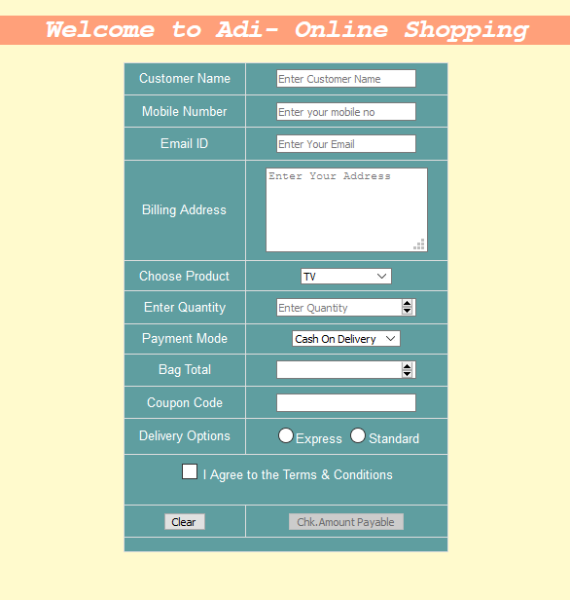

**Use Case 1:A Complete filled Form Coupon Code Applicable-for Cash On Delivery,Express option mode & upon agreeing Terms and Conditions**

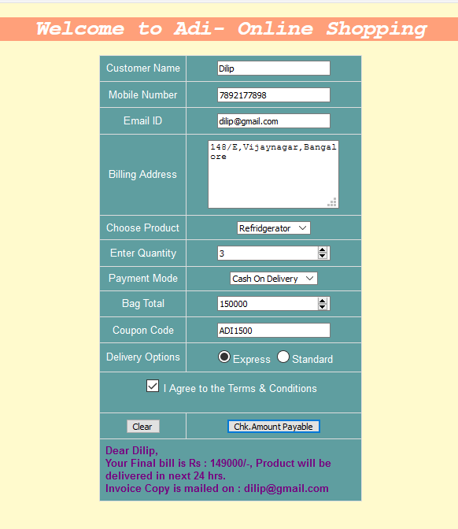

**Use Case 2:A Complete filled Form for Inapplicable Coupon Code-DebitCard,Standard delivery option & upon agreeing Terms and Conditions**

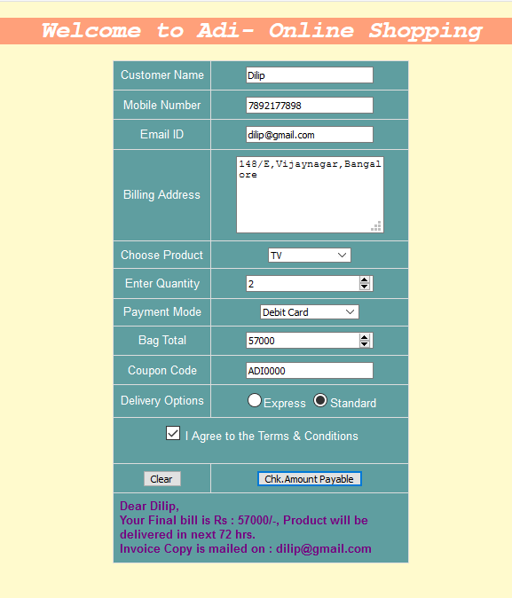

**Use the Label Name and the Component Id as given. The Component Id is case sensitive. All the necessary attributes for the Components should be given.**

**The Component Id should be specified for each HTML Component. If the Component Id is not provided for a HTML component, the marks will not be provided for this component.**

**All Tags, Elements and Attributes should conform to HTML5 Standards. All the fields are mandatory.**

Provide the details as given in the table below.

|  |  |  |
| --- | --- | --- |
| Req. # | Req. Name | Req. Description |
| 1 | Design a “Adi Electronics-Online Shopping” with the specified fields. | |  |  |  | | --- | --- | --- | | **Label Name** | **Component  Id** | **Description** | | Heading | heading | label for  Welcome to Adi- Online Shopping | | Table | Ebill | Table id is Ebill | | Customer Name | custname | To Enter Customer’s Name  **Design Constraints:**  The text “*Enter Customer Name****”*** should appear by default.**.**  **Customer Name should contain only Alphabet/s and can have spaces**  **It should be mandatory.** | | Mobile Number | mobileNumber | To enter Mobile Number of Customer  **Design Constraints:**  It should be 10 digits and should start with 7 or 8 or 9.  The text *"Enter your mobile no****”*** should appear by default.  **It should be mandatory.** | | Email ID | email | To enter Customer’s Email Id  **Design Constraints:**  **provide validation such that email includes @ and . symbol and is in smaller case**  **T**he text “*Enter Your Email”* should appear by default.  **It should be mandatory.** | | Billing Address | address | To Enter Customer’s Billing Address  **Design Constraints:**  Use appropriate form control to hold 5 rows and 20 cols.  The text “*Enter Your Address”* should appear by default.  **It should be mandatory.** | | Choose Product | product | To Choose the Product  **Design Constraints:**  Use appropriate input drop down type so as choose one of the following product.   |  |  |  | | --- | --- | --- | | **id** | **value** | **Product Name** | | TV | 1 | TV | | Fridge | 2 | Refridgerator | | Mobile | 3 | Mobile | | | Enter Quantity | quantity | To Enter the number of products needed  **Design Constraints:**  The text “*Enter Quantity”* should appear by default. Ensure that minimum quantity that can be ordered is 1  **It should be mandatory.** | | Payment Mode | mode | To choose the mode of payment by the customer  **Design Constraints:**  Use appropriate input drop down type so as choose one of the following payment mode.   |  |  |  | | --- | --- | --- | | id | value | payment -mode | | Cash | 1 | Cash On Delivery | | Debit | 2 | Debit Card | | UPI | 3 | UPI Transfer | | | Bag Total | bill | Finds the bag Amount based on product,quantity and Payment Mode.  **Design Constraints:**  Provide proper Input Type to hold a number.  When this field gets focus,BagTotal amount should get auto calculated.This is done by providing code in Js function calculateBagTotal().  It should be Mandatory | | Coupon Code | coupon | This field computes Coupon Code in form:ADI followed by 4 digits  **Design Constraints:**  Provide proper Input Type to hold the above mentioned format.  When this field gets focus,Coupon Code should get auto generated.This is done by providing code in Js function calculateCoupon().  Coupon Code is **Non editable** and is mandatory. | | Delivery Options | delivery(name) | To Choose Delivery Option  **Design Constraints:**  Use appropriate input type so that customer can choose only one of the 2 option 1)Express and 2)Standard.   |  |  |  | | --- | --- | --- | | **id** | **name** | **Values** | | express | delivery | Express | | standard | delivery | Standard |   Choosing one of the option is mandatory | | I Agree to the Terms & Conditions | terms | To Agree to Adi Electronics Terms and Conditions.  **Design Constraints:**  When this field is checked invoke JS function activateButton(this) and provide code to activate Submit Button | | Submit | submit | The input type submit must be used. | | Clear | reset | Reset Button.  On clicking this button, all fields should be reset and submit button should get disabled |    NOTE: The text highlighted in bold in the Description needs to be implemented in the code to complete the web page design. |
| 1 | Apply the mentioned styles using CSS to the components | **1.**  The **heading** the text color should be **“***#FFFFFF***”**, font should be **“Courier New”**, background color should be **“***#ffa07a*”  **2.**body background color should be *#fffacd.*  **3.** **table id** should be **“Ebill”**. The font should be “**Arial**”, width should be **“300px“, background-color should be** *#5f9ea0* ,color:**white,text aligned to center,border-collapsed**  **4.** The **table** should have the “padding-top” attribute’s value as **“12px”**,”padding-bottom” attribute’s value as **“12px**”.  **5.** **The table header and each cell’s** border should be **“2px solid #ddd”** and the padding attribute should have the value **“8px”.**  **6.**result should be displayed in a div tag with id result within the table with color *#770080,*font-weight: *bold.*  Note: Fill in the style tag so that the given styles are applied to the components.  **Refer to screen shot for other css styles and apply as needed.**  **Note:(Please use External CSS and External JS)** |
| 2 | Use JavaScript for | Use JavaScript method **calculateFinalAmount**() for doing necessary operations/calculations and to display the result :  When the Adi-Online Shopping form is submitted with valid values and clicks the “Submit” button, the form result should be displayed as follows:  Dear <<CustomerName>>, Your Final bill is Rs : <<Amount payable>>/-, Product will be  delivered in next <<24/72>> hrs. Invoice Copy is mailed on : <<Email id>>  **The product and its Cost is as shown in the table**   |  |  | | --- | --- | | **Product** | **Cost/Price per Unit** | | TV | 30,000 | | Refridgerator | 50,000 | | Mobile | 20,000 |   **Validations in JavaScript:**  1.**calculateBagTotal()** function calculates Bag Total.  **Example:**  A customer buys 5 TV’s pays by Debit Card  Then price of 5 TV’s is 150000/-  Debit Card gets him 5% discount  then **Bag Total=1,42,000/-** .  If Customer pays by Cash On delivery or UPI Transfer  then **Bag Total=1,50,000/**-  **2.** **calculateCoupon()** function is based on **BagTotal**.  if BagTotal is Rs.1Lakh and above then Coupon Code **ADI followed by first 4 digits of BagTotal** gets generated.  if BagTotal is less than a lakh then **COUPON CODE ADI0000** gets generated.  Eg:If BagTotal is Rs.142000 then Coupon Code generated is **ADI1420**  **3.**when the form is loaded in browser, **disableSubmit()** function in JS is called to disable submit button(Code already given)  when Terms and Condition checkbox is checked,invoke  **activateButton(this)** in HTML and write JS code for this function to check if submit is disabled.If disabled,Enable submit Button.  **Note:Submit Button should also get disabled when form is cleared.**  ***4****.A product delivered through Express Delivery will be delivered in 24 hrs with an addition charge of Rs. 500/- .*  ***5****. A product delivered through Standard Delivery will be delivered in 72 hrs with no addition charge .*  ***6.*** ***calculateFinalAmount()*** *in JS is invoked when customer submits the form to find Amount Payable.*  ***Amount payable****=[Bag Total-(4 digits of Coupon Code)]+Delivery charges if applicable*  ***The result should be displayed in***   in a div tag with  id  “result”.  Note: Use the getElementById() or getElementsByName() function to retrieve the values. |
| 3 | Form tag with attribute onsubmit | **Include form** Tag in the code template. Do not change the code template and do the coding as per the requirements and specification.  Make sure that the onsubmit attribute in the form tag is invoking the JavaScript function like "**return calculateFinalAmount()**".  Also ensure that “return false;” statement is the last line of the JavaScript function **“calculateFinalAmount()”.** |